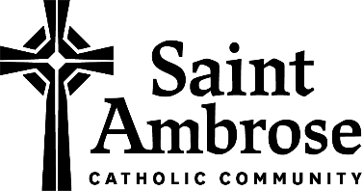
Saint Ambrose Small Groups
Interest/Registration

We are excited to begin Small Group Ministry at Saint Ambrose! Please indicate which potential Small Group(s) you may be interested in and when you are available to meet. Small Groups will be formed and organized during the month of December and will begin in January or at the discretion of each Small Group. Watch the bulletin and parish website for more information and details.

- Contact Information:

Name: ______________________________________________________________________________

Phone Number: ______________________________________________________________________

Email Address: _______________________________________________________________________

- Gender (circle one): Male Female

- I am interested in joining the following potential Small Group(s) at Saint Ambrose:

Age-related Small Group. Please specify:
____ Young Adult (20 – 39 years old)
____ Middle Age (40 – 64 years old)
____ Seniors (65 and older)

State of Life-related Small Group. Please specify:

____ Single
____ Dating
____ Engaged
____ Married
____ Parenting
____ Separated or Divorced
____ Widowed
____ Other: Vocational Discernment

Adult Formation (learn about the Catholic faith)

Apologetics (learn how to defend the Catholic faith)

Book Club

Faith Study. Please specify your interest, for example Bible Study or Saint Study:

_________________________________________________________________________

Prayer Group. Please specify your interest: _____________________________________

_________________________________________________________________________

Volunteer/Service Group. Please specify your interest: ___________________________

_________________________________________________________________________

Support Group. Please specify your interest: ____________________________________

_________________________________________________________________________

Other. Please explain: ______________________________________________________

_________________________________________________________________________

- For a Small Group, I prefer to meet: ____ At Church ____ At Home

I am available to meet on:

 | Sun | Mon | Tues | Wed | Thurs | Fri | Sat
Morning

Afternoon

Evening

- Please share any comments you may have with us here:

____________________________________________________________________________________

____________________________________________________________________________________

- I am willing to be a facilitator or leader for my Small Group. ____ Yes ____ No

Please return this form to the Parish Office by Tuesday, November 30.

